# Mission/Challenge

Create a responsive (phone, tablet, desktop) web application that allows the user to quick filter a list of things. The top of the page will have a search input field and then below that a list of things in response to the filter. The things should be sorted alphabetically. The things could be anything, but should be AJAX pulled from a backend service that you write and should ultimately be pulled from an open public API.

Here’s an example list of API’s curated on GitHub, <https://github.com/toddmotto/public-apis> but feel free to use any public API you wish.

**Solution:**

1. From the above mentioned List of APIs <https://github.com/toddmotto/public-apis>, Books Index with Open Library API is taken as example.

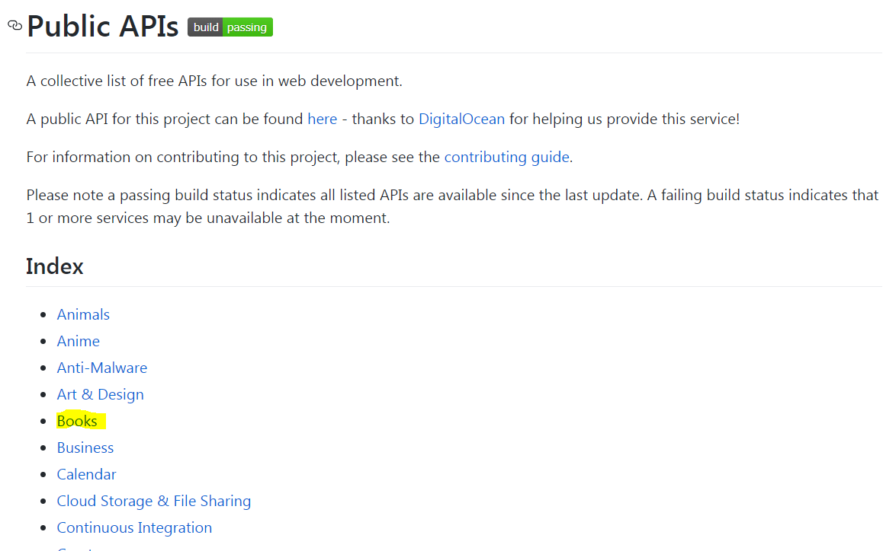

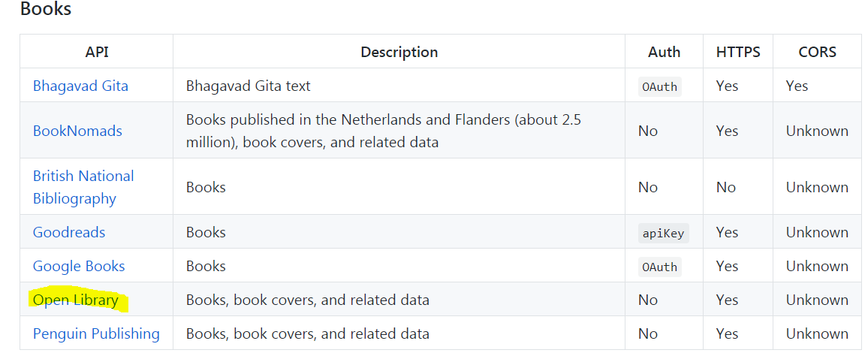

1. The scope of the project is to make a REST API call to get the list of Books available in Library and get additional details about Author and check whether softcopy is available , or not.
2. <https://openlibrary.org/subjects/textbooks.json> API gets the list of books available to browse.

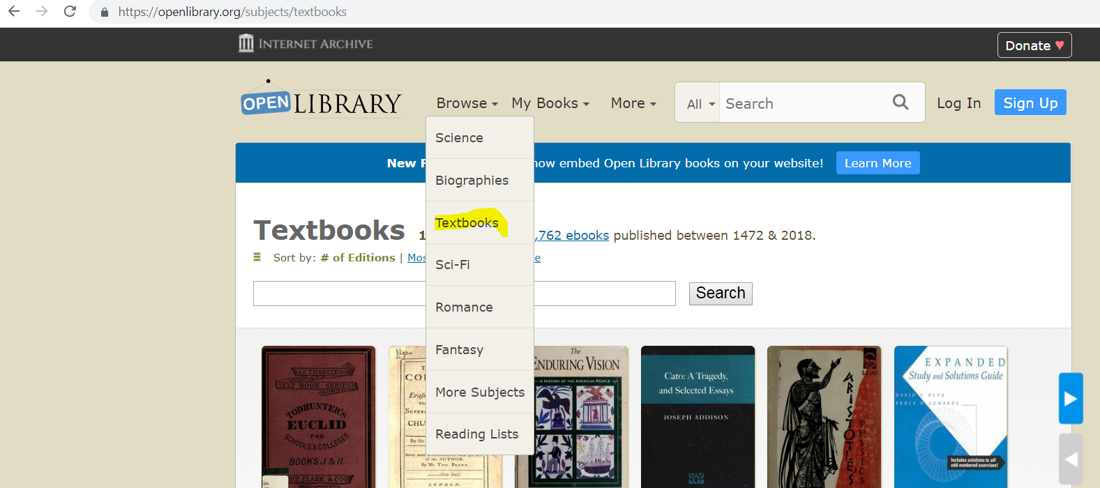

1. A web based solution is provided by using Spring MVC, REST API services with frontend technologies as such html5, jQuery, AJAX, javascript. Project is developed by using Java 1.8 with Maven and can be deployed on tomcat (or) jboss application servers.
2. Tools/softwares used: eclipse, maven, git, java 1.8.
3. Context root : **booksresponsiveproject**

Application URL: [**http://localhost:8080/booksresponsiveproject/**](http://localhost:8080/booksresponsiveproject/) **( when running locally)**

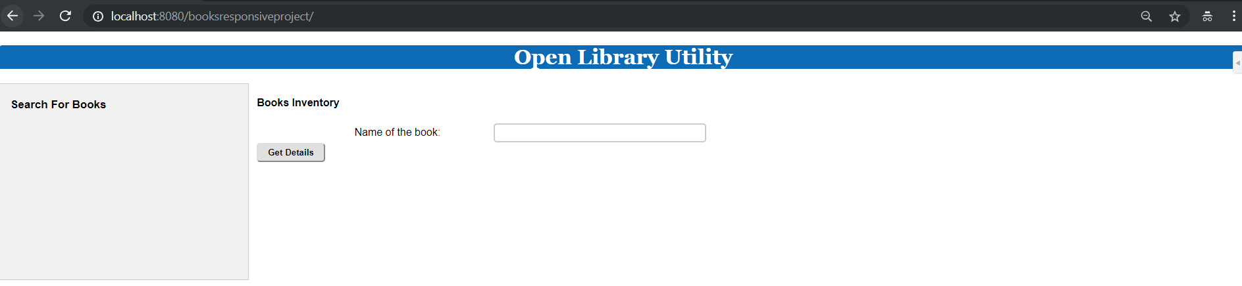

1. Leftside panel is developed to add more options in future ( based on requirement)
2. Name of the book is the text field – where AJAX calls are implemented. As soon as user types partial book name/ full book name/ or simply a letter, an AJAX call triggered immediately, blocks the UI actions and get the list of available books in the Inventory

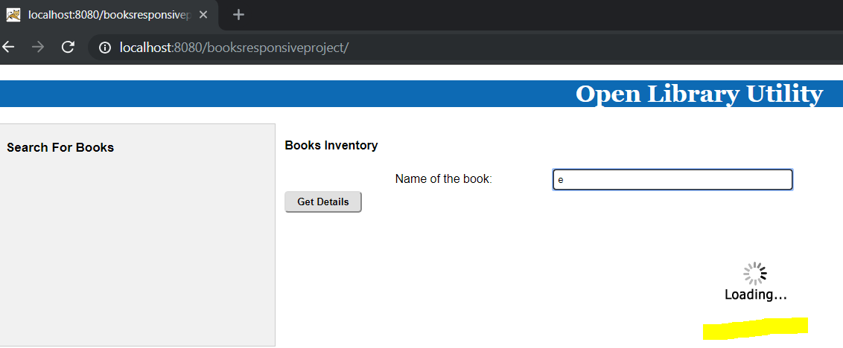

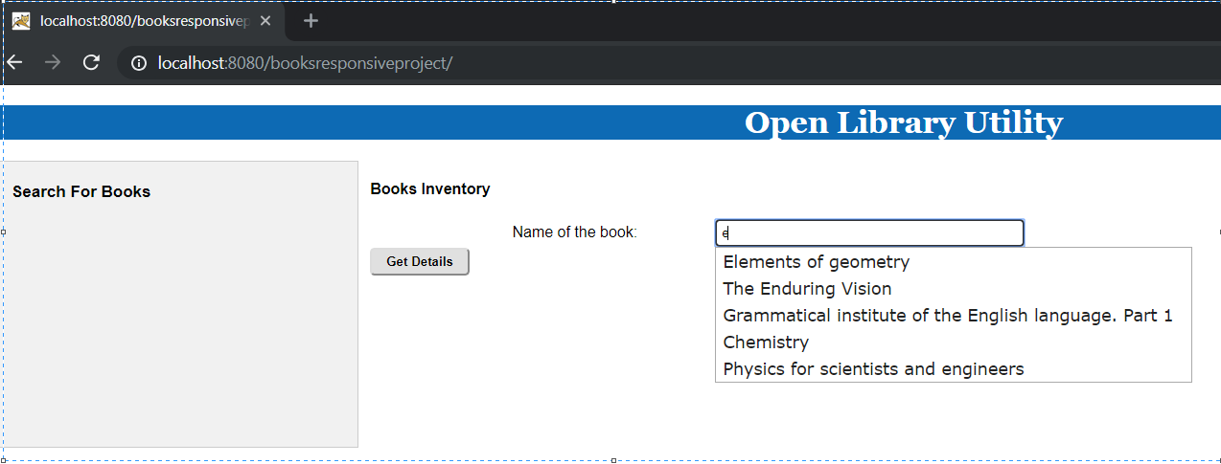

1. AJAX call is made to REST API to pull the Name of the books which contains letter **‘e’** and gives the option to user to select the Book Name from the list.
2. Once, user selects the book and click on “Get Details” , then user can view the details about the book as such author details- key and printable version status.

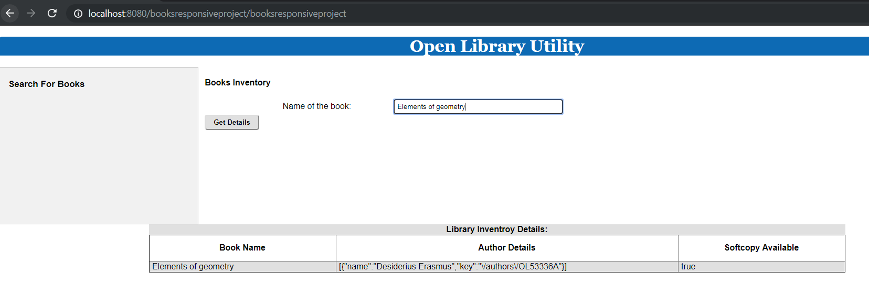

1. It also gives the provision to search by single letter . ex **c**  and displays all the available books in Inventory which has letter **c** in it. This is **like** search.

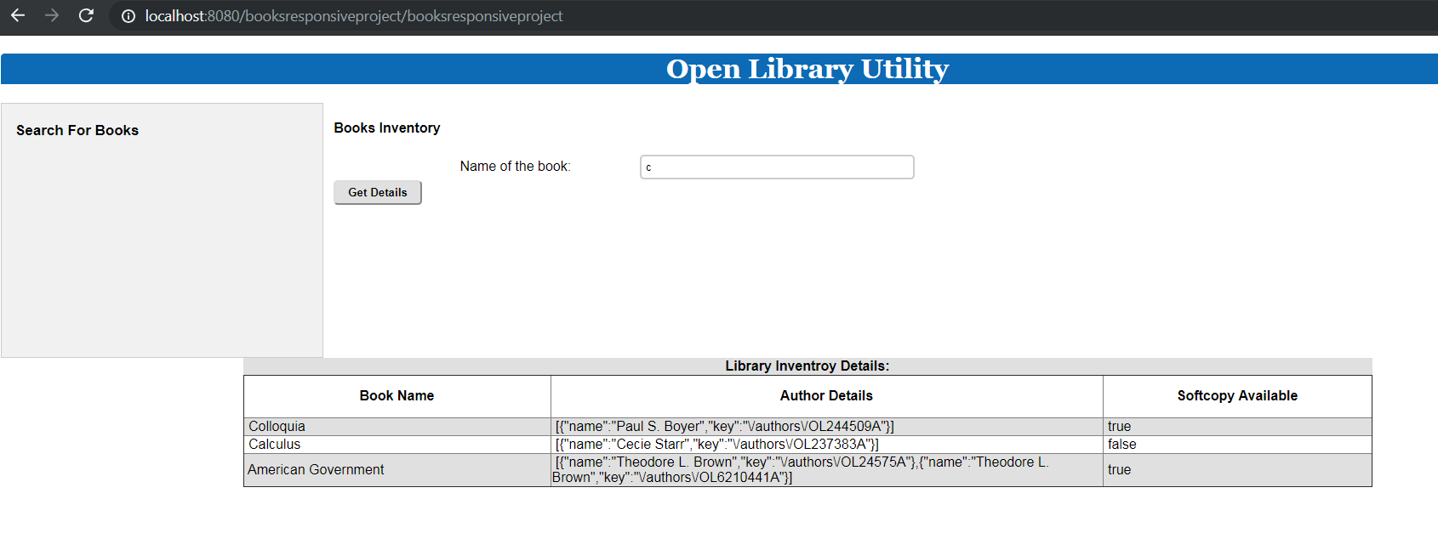

1. Project Structure

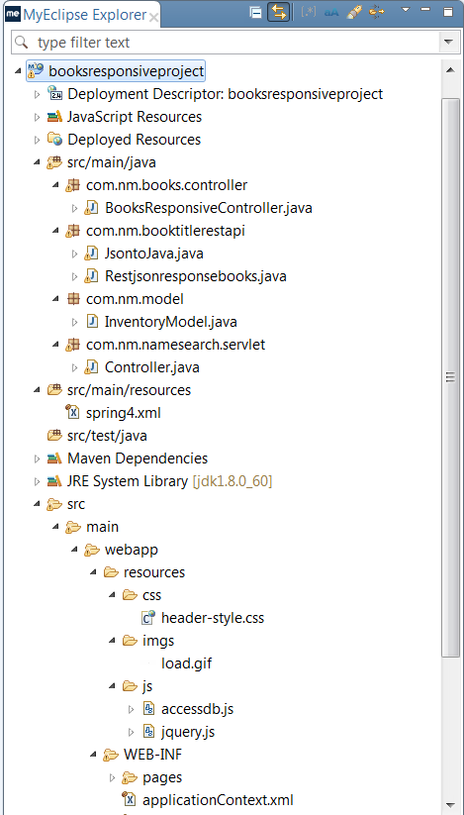

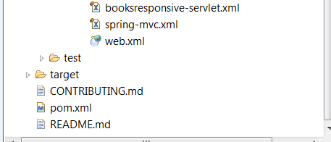

1. Source code is attached herewith.



Project is also uploaded in Git here: <https://github.com/maheshnm/booksresponsiveproject.git>

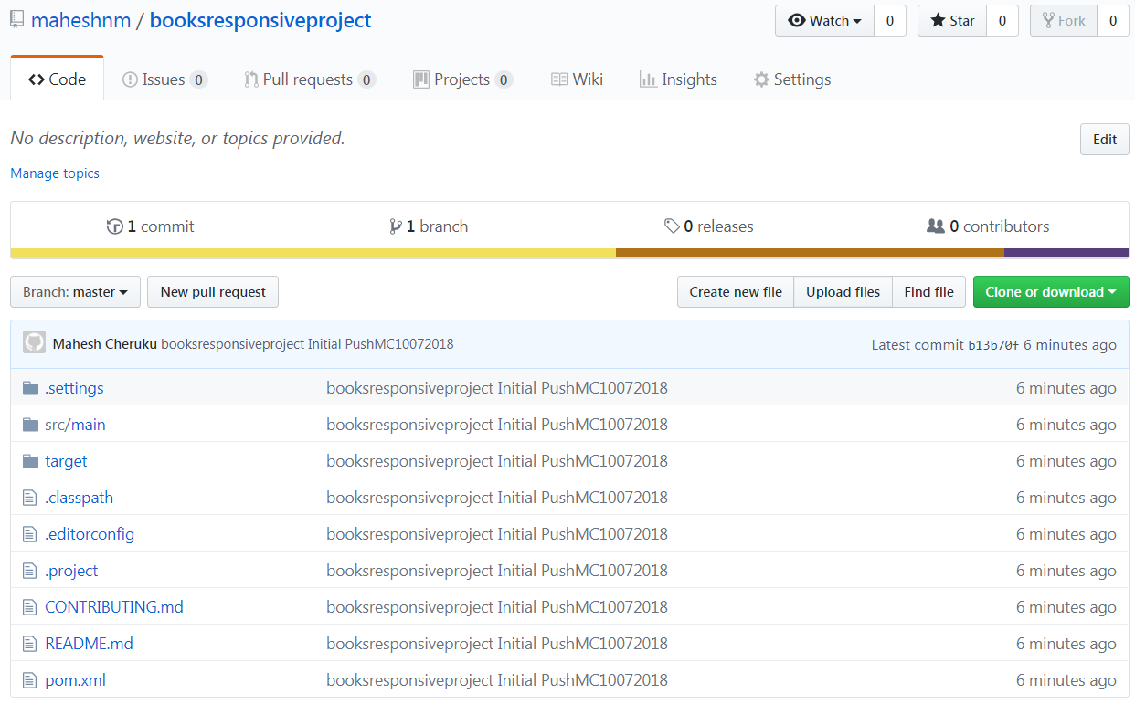

|  |  |  |
| --- | --- | --- |
| **Document History** | **Created by** | **Contact details** |
| Initial Version | Mahesh Cheruku | 224-386-9933  mcherukuit@gmail.com |